Capt Lakshmi Gopidas
Assistant Professor of Microbiology and Associate NCC Officer
Department of Biochemistry and Microbiology
Sree Narayana College for Women, Kollam

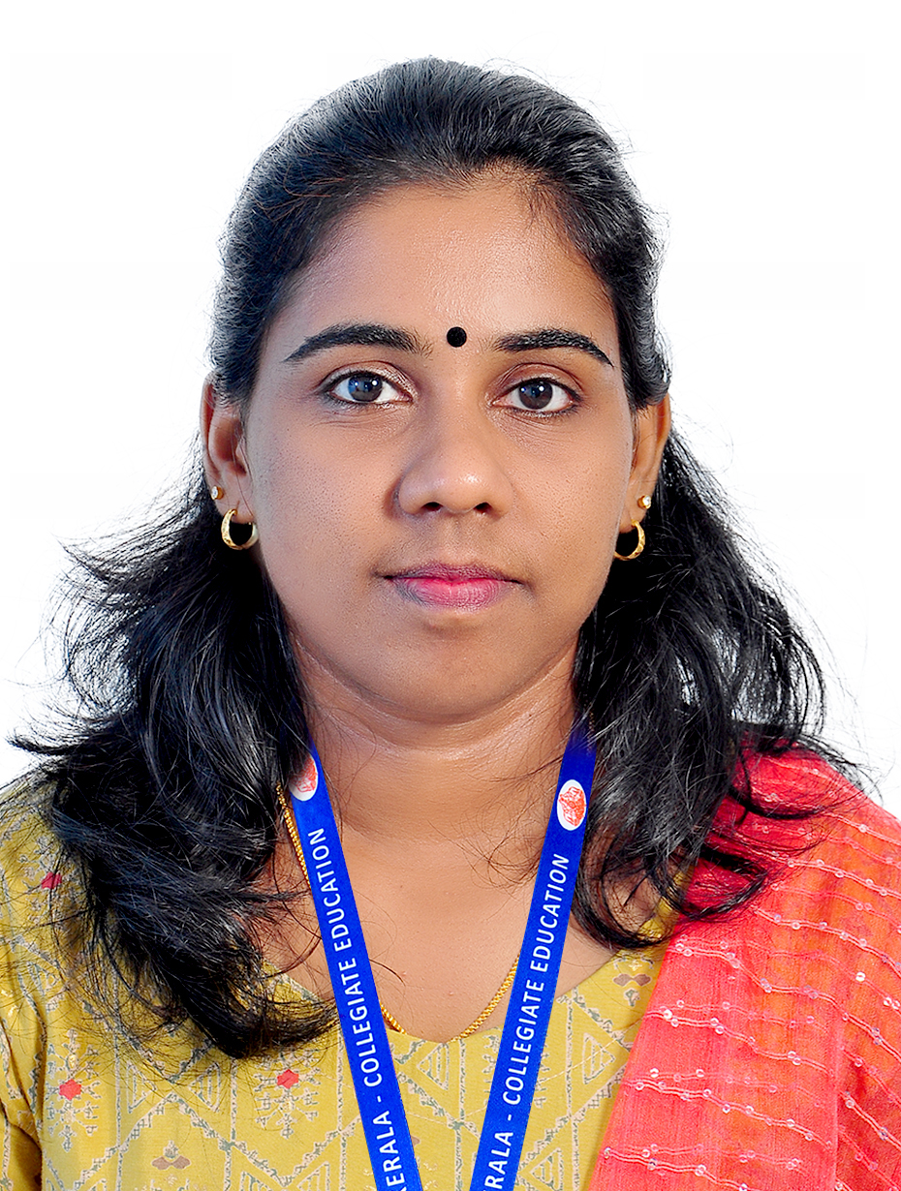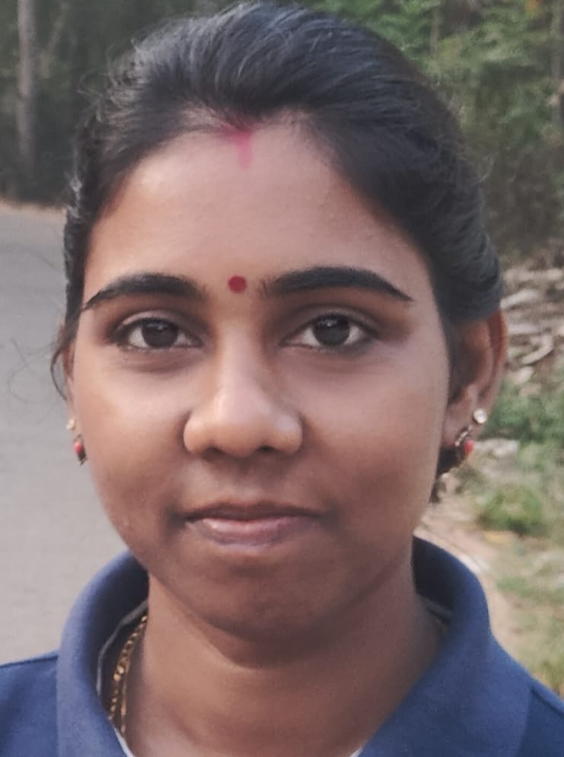

ADDRESS & EMAIL
Kalathil house,villoonni p o,Arpookara, Kottayam, lakshmigk1@gmail.com

QUALIFICATION
Msc. Microbiology,NET
DATE OF JOINING
07.01.2011
EXPERIENCE IN YEARS
13 yrs

ADMINISTRATIVE DISTINCTION
- MEMBER OF BOARD OF STUDIES of Microbiology,University of Kerala from 2020 onwards
- ASSOCIATE NCC OFFICER from 2012 onwards.Underwent Refresher Course at NCC OTA Gwalior
- Member of Sports Club
- Discipline Committee Member.

PARTICIPATION IN SEMINARS/ CONFERENCES/ WORKSHOPS
- Participated in the UGC sponsored National seminar on Emerging Trends in Materials Science organized by Department of Chemistry, S.N. College for Women from 29th September to 1st October 2014.
- Participated in the National Seminar on “Challenges and Changes in AQAR and SSR Preparation” organized by the Internal Quality Assurance Cell (IQAC), SreeNarayana College for Women, Kollam, Kerala on 19 & 20 December 2019.
- Participated in the One Day Seminar on “Ayyankali and Social Changes in Kerala” organized by the Department of History, SreeNarayana College for Women, Kollam, Kerala on 30th August 2019.
- Attended an International Webinar on Autoimmunity & Antimicrobial Response factors organized by Department of Biochemistry & Industrial Microbiology & IQAC S N College for women,kollam on 27th july 2020.
- Participated in the online Ek Bharat Shresth Bharat Saptah organized by NCC group headquarters Kota (Rajasthan) from 16 th August 2020 to 21st August 2020.
- Participated and successfully completed the one week online short term faculty development program on ICT Tools for Teaching & Learning process-post pandemic educational strategies organized by Sree Narayana College ,kollam in collaboration with The Kerala state Higher Education Council from 17th August 2020 to 23rd August 2020.
- Participated in the International Webinar on Outcome based education organized by department of Mathematics with IQAC, TKMM College Nangiyarkulangara on 15th January 2021.
- Attended an International Webinar on Gandhian values :Tool for effective management of world order during Covid -19,organized by University of Calicut & Gandhi Centre Trivandrum during 4th February 2021 to 6thFebruary 2021.
- Attended a virtual session on Patent: A journey from Innovation to Establishment on 27th February 2021 Organised by Thakkur College of Science & Commerce.
- Attended a virtual session on Importance of Intellectual Property in Universities & Colleges on 27th February 2021 Organised by Thakkur College of Science & Commerce.
- Attended a virtual session on Research Publications & Patents: Comparing & Contrasting on 27th February 2021 Organised by Thakkur College of Science & Commerce.
- Participated in the webinar on “Importance of Youth” on National Youth Day 2022.

ORIENATION PROGRAMMES ATTENDED:
- Underwent the UGC - Sponsored Refresher Course –summer School conducted by the UGC – Human Resource Development Centre, University of Calicut, Calicut from 06/05/2015 to 26/05/2015.
- Underwent the UGC - Sponsored Refresher Course (Biosciences) conducted by the UGC – Human Resource Development Centre, University of Calicut, Calicut –from10/01/2018-30/01/2018.
- Successfully completed one week online National faculty Development Program on “Media & Art in Teaching & Learning (interdisciplinary) jointly organized by Guru Angad Dev Teaching & learning centre, SGTB Khalsa college,University of Delhi Under Pandit Madan Mohan Malaviya National Mission on Teachers & Teaching of Ministry of Education & Bishop moore College , conducted from 12th January 2021 to 25th January 2021.
- Successfully completed two week interdisciplinary refresher course in Managing classes & C creating MOOCs from 02nd June to 16th June 2021,organised by Teaching and Learning Centre ,Ramanujan College University of Delhi.
- Successfully completed two week interdisciplinary refresher course in Advanced Research Methodology from 21st June to 05th July 2022,organised by Teaching and Learning Centre ,Ramanujan College University of Delhi.
- Underwent Refresher Course at NCC OTA Gwalior from 3rd Oct to 22nd October 2022.

